1. Requirements for participation. In order to participate in this study, you must be a heterosexual male between the ages of 21 and 50.
2. Content warning. This experiment involves pictures of *women in lingerie* (non-nude). If you are uncomfortable with viewing such content, please exit the task here.
3. Consent. This experiment has been approved by the Ethics Committee. No harm will come to you from taking part in this experiment. You have the right to stop at any time. Thank you for agreeing to take part in this experiment! Before we continue, we need your consent to the following: (1) I consent to performing the task online. (2) I understand and consent to my responses are being recorded and stored securely in a database. (3) I understand and consent to my responses may be used anonymously for secondary research in the future. Click ‘Continue’ to consent and proceed.
4. Welcome! This experiment is composed of 3 tasks, which in total should take around 30 minutes. Before each task begins, we will provide detailed instructions for that task and some practice. In Task 1, you will respond to which side of the screen an image appears on. In Task 2, you will choose between two fractals that appeared in Task 1. In Task 3, you will rate how much you liked each image in Task 1.
5. Compensation. If you finish the experiment, you will be compensated $20 for your time. At the end of the experiment, we will randomly select one trial from Task 1. If you correctly answered in that trial, you will be awarded an extra $10.
6. Are you ready to start?
7. Instructions for Task 1. In Task 1, you will be asked to press the left or right arrow key depending on which side of the screen a target image is on. Each trial will begin by showing you a progress bar that indicates how much of Task 1 you have completed. This will be displayed for 1 second.

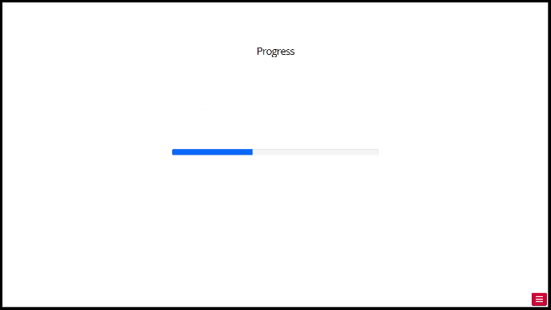

1. After the progress bar, you will be presented with a 1 second information screen. A pie chart will appear. Green represents the probability of viewing a rewarding image (a woman in lingerie). Empty (white) represents the probability of no rewarding image. The pie chart may appear on either the left or right side of the screen. On some trials, the pie chart will be accompanied by a fractal image on the opposite side of the screen.

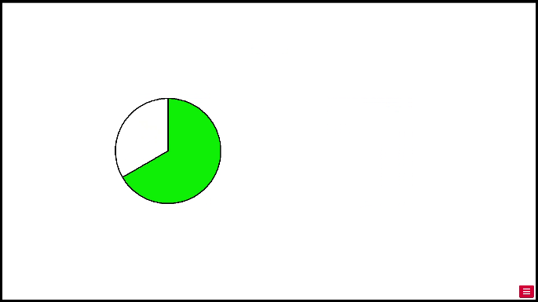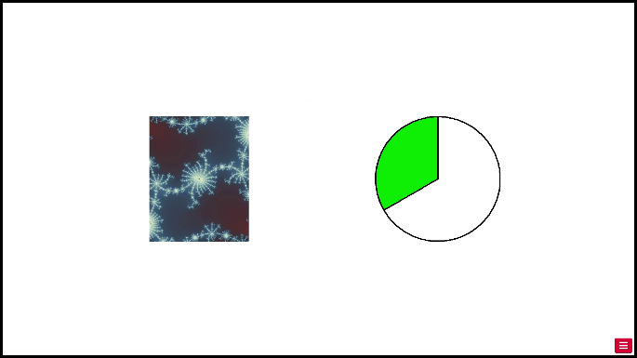

1. After the information screen, you will see "wait" on the screen for roughly 2 seconds. Text, letter

   Description automatically generated
2. After waiting, either the rewarding image (a woman in lingerie) or a "no image" icon will appear. They can appear on either the left or right side of the screen. Your task is to **press the left or right arrow key depending on which side of the screen the woman or "no image" icon is**. Once you've made your selection a black box will highlight your choice, regardless of whether your choice was correct. In the example below, a rewarding image was shown on the left side of the screen, so you should select left.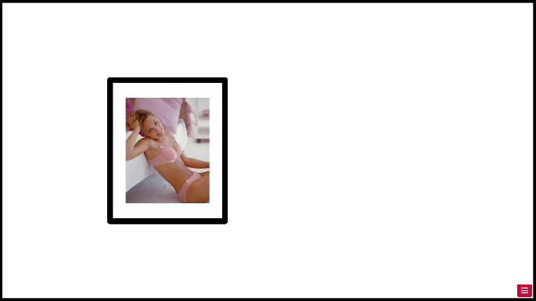
3. Here is an example of the "no image" icon. The "no-image" icon appeared on the right side of the screen, so you should select right.

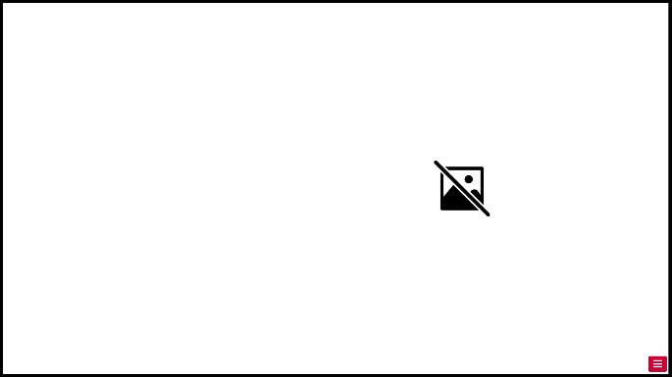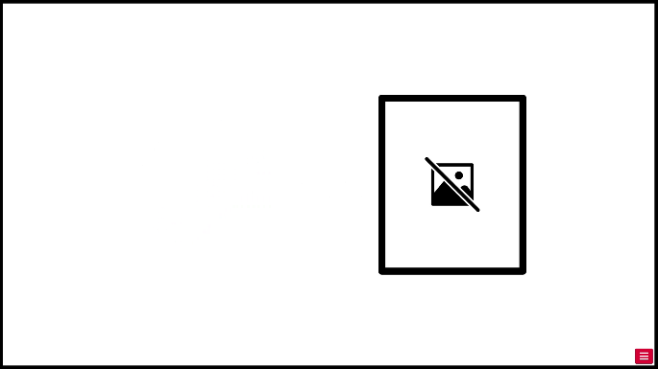

1. On some of the trials, the rewarding image - or "no image" icon - will be accompanied by a fractal image on the opposite side of the screen. Regardless of the fractal image, your job is still to press left or right according to the location of the rewarding image or "no image" icon. In the example below, the rewarding image appeared on the right side of the screen, so you should select right.

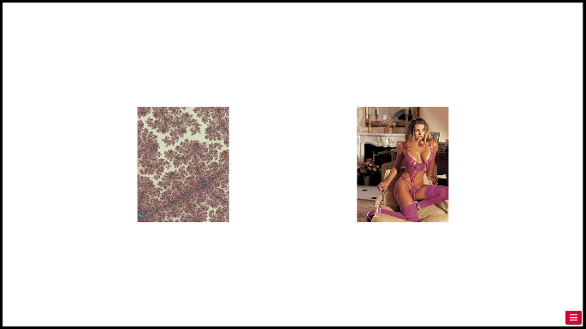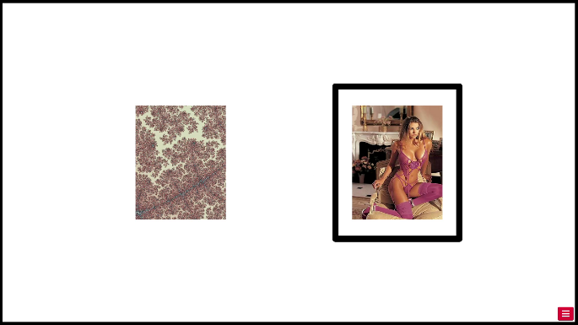

1. Task 1 consists of 144 trials, split into 2 blocks of 72 trials each. Each block will begin with a screen that notifies you that the new block is starting. This screen will also show you a set of pie charts. **These are the only pie charts that are possible during this block.** This screen will also tell you what the average probability is for this block.

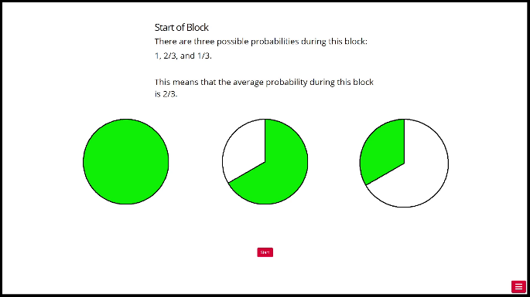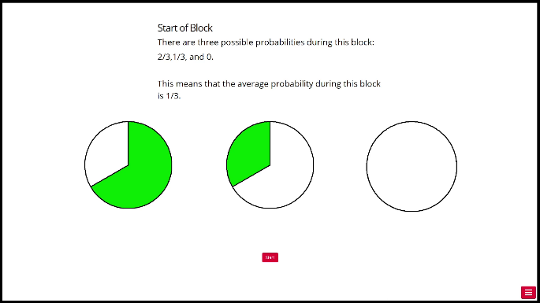

1. Before starting Task 1, let's practice with 10 practice trials. We'll keep track of your accuracy and let you know how you did after the practice trials. Are you ready to start practicing?
2. Start of Practice Block. There are four possible probabilities during this block: 1, 2/3, 1/3, and 0. This means that the average probability during this block is 1/2.
3. Practice complete! Your practice accuracy was: __ %.
4. Are you ready to start Task 1?
5. Start of High Probability Block. (Image is missing “High Probability”)

1. Start of Low Probability Block. (Image is missing “Low Probability”)

1. End of block. Feel free to take a break! Press continue to resume experiment.
2. End of Task 1. Press continue to move on to Task 2.
3. Instructions for Task 2. In Task 2, you will be choosing a fractal from a pair. You've seen these fractals before, during Task 1.
4. At the start of a trial, you will see your progress in Task 2 for 1 second.

1. After the progress bar, you will be presented with two fractals on the left and right sides of the screen. **Please choose the fractal that you prefer.** You have 2 seconds to make a choice. If you do not choose fast enough, you will be met with a prompt to choose faster next time.

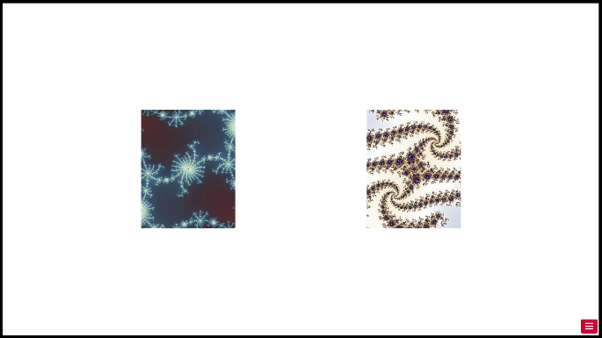

1. Once you've made your selection, you will see a waiting screen for 1 second.

1. After waiting, you will be presented with the associated pie chart and/or image for your choice. These are linked to what you observed in the previous task when that fractal was presented.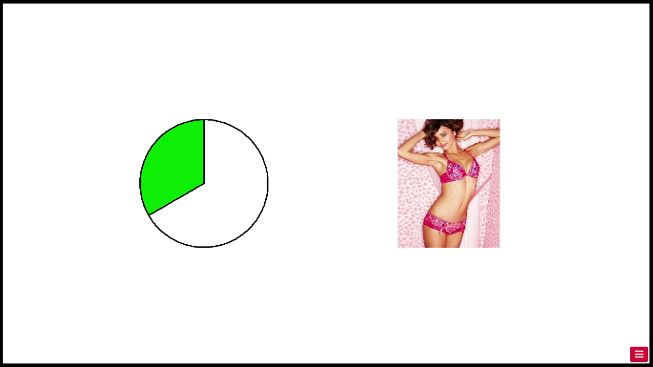
2. Are you ready to start Task 2?
3. End of Task 2. Press continue to move on to Task 3.
4. Instructions for Task 3. In Task 3, you will be asked to rate how much you liked each rewarding picture.
5. At the start of a trial, you will see your progress in Task 2 for 1 second.

1. After the progress bar, you will see the rating screen. One of the rewarding images will appear on the top of the screen. Below that will be a set of 5 buttons indicating how much you like or dislike the image. Please click the rating that corresponds with how much you like the image. There is no time limit for each choice. Graphical user interface, text

   Description automatically generated
2. Are you ready to start Task 3?
3. End of experiment. Thank you for participating!